What is an ICA (Instructions for Continued Airworthiness) Supplement?
ICA supplements may be produced to transmit supplemental instructions for continued airworthiness when a revision to the maintenance manual is not possible within the time constraints for these ICAs. ICA supplements will provide supplemental instructions for one or more ICA manual and is to be used in conjunction with the affected manuals (maintenance manual, wiring diagram manual, etc.) until those instructions are incorporated into the manuals. ICA supplements are numbered consecutively by model in the ATA chapter assignment. Page numbering uses the three-element number, which matches the affected manuals.
You can find ICAs by selecting the Service link on the Library TOC in 1View or by directly accessing the Service Information website. See the FAQ “Where Can I Find All Applicable Cessna ICA (Instructions for Continued Airworthiness) Supplements?” for step-by-step instructions.

Where Can I Find All Applicable Cessna ICA (Instructions for Continued Airworthiness) Supplements?
It’s possible more ICA Supplements are available for your aircraft than those bundled within the 1View library. You can locate all released Instructions for Continued Airworthiness (ICA) from the online Service Information website: https://ww2.txtav.com/TechnicalPublications/SI/OnlineServiceInformation.
- Already logged into 1View?
  - No. Continue to Step 2.
  - Yes. Select the Service category link on your library’s webpage. Continue to Step 5.
- Log on and sign into the Textron Aviation Technical Publications website: https://ww2.txtav.com/TechnicalPublications/
- Select Service Information from the top menu.
- Under Switch to…, select the Make for your aircraft. Continue to Step 5.
- On the Service Information web page, search for released ICA documents as follows.
  - Select your Model: click the applicable radio button for Jet or Turboprop/Piston and then select your model from the dropdown menu.
  - (Optional) Select your Serial from the dropdown menu.
  - To narrow your search to a modification, type a subject in the Title Description field, such as Garmin. Otherwise, continue to Step d.
  - Under Publication Type, unselect all checkboxes except ICA.
  - Click the Search button. A list of released ICAs for that model appears under Search Results. The screen will display similarly to that shown below.
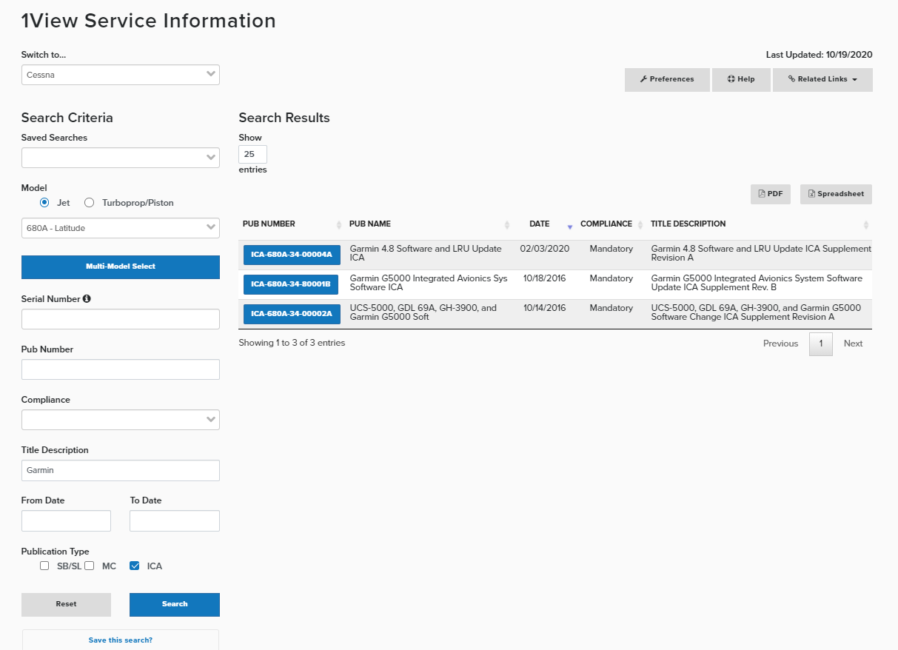
- You can save this Search as well.
  - Select the Save this search? link at the bottom of the page.
  - Type a name in the Search Title box that displays.
  - Select Save.
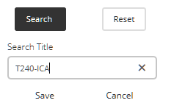
- To use this search again, do the following:
  - See Search Criteria > Saved Searches, select the named search you created from the dropdown menu.
  - Select the Search button.
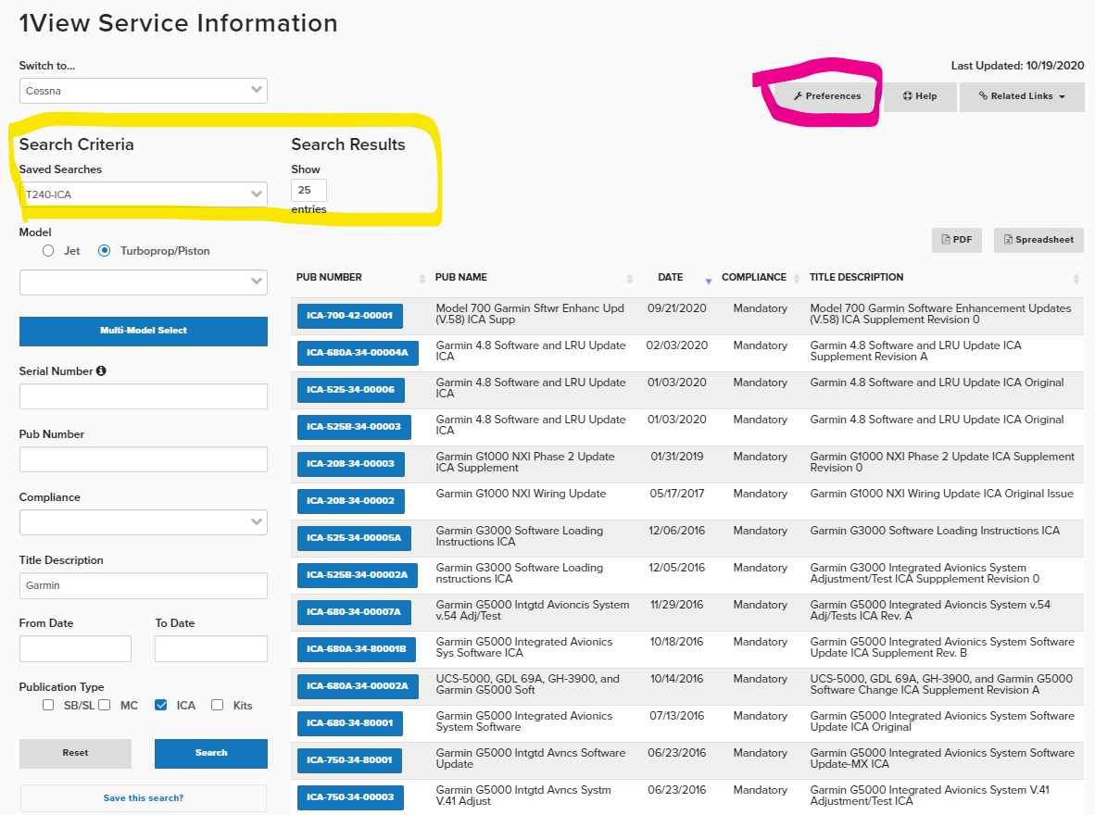
- You can manage saved Searches by selecting Preferences at the top, right screen.
